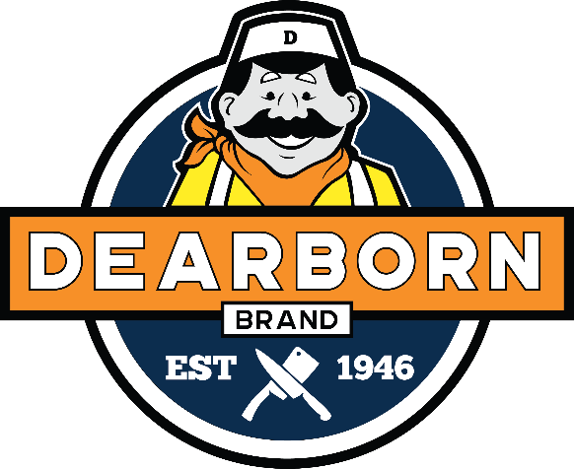  Organization’s Name  Seller’s Name |  | Half Spiral Sliced Torch Glazed Ham - $48.90 | Whole Spiral Sliced Glazed Ham $84.90 | Half Spiral Sliced Ham/Glaze Pkt - $43.90 | Whole Spiral Sliced Ham/Glaze Pkt - $76.90 | Whole Classic Semi Boneless Ham –$59.90 | Half Classic Semi Boneless Ham - $33.90 | Hunters Sausage (Hot) - $42.90 | Hunters Sausage (Mild) - $42.90 | Smoked Kielbasa - $26.90 | Fresh Kielbasa - $26.90 | Beef Skinless Franks - $26.60 | Skinless Franks - $21.25 | Natural Casing Franks - $15.70 | 1904 Brand Hot Dogs -$17.70 | Honey Cured Thick Sliced Bacon 1.5lb package $13.90 | Applewood Thick Sliced Bacon 1.5lb package $13.90
Name | Phone # | 6006 | 6005 | 6002 | 6001 | 6003 | 6004 | 6026 | 6027 | 6021 | 6023 | 6040 | 6041 | 6042 | 6049 | 6080 | 6081
 |  |  |  |  |  |  |  |  |  |  |  |  |  |  |  | `
 | TOTALS
TOTAL $

