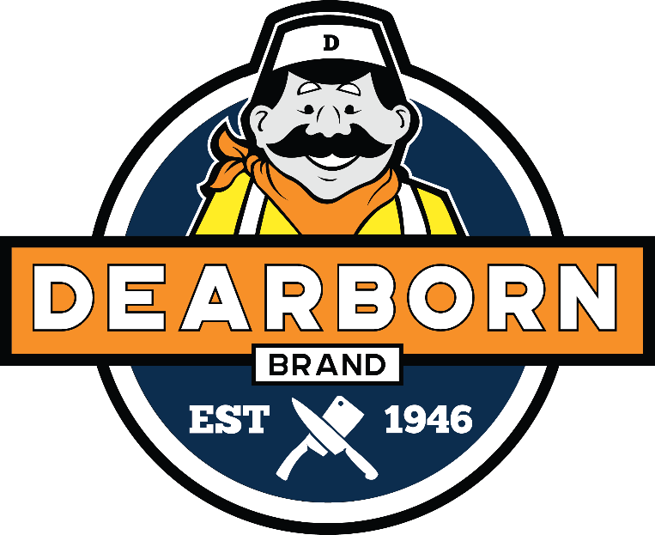

FUNDRAISER

A History of Quality
For more than seven decades, Dearborn Brand has maintained a far-reaching reputation for excellence, while staying rooted in our community and workforce. We are a family business that has adapted with the changing times, expanding our state-of–the-art facility to 85,000 square feet, which is capable of producing large volumes and specialty items of Dearborn Brand or custom products.
A Commitment to the Community
At Dearborn Brand, we are rooted in our community and committed to supporting those who have long supported us. That’s why we created a fundraising program that is as easy as it is delicious. The more you buy, the more your organization earns- so start stocking up on your Dearborn favorites.

WWW.DEARBORNBRAND.COM

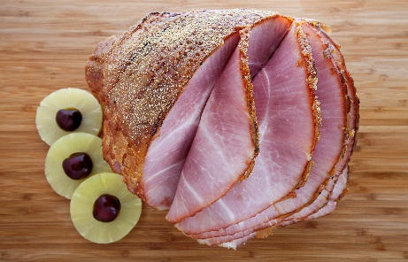
FRANKS
6040- BEEF SKINLESS FRANKS (5 LBS) – Try our premium gluten free all beef hot dogs that will always take you back to that authentic taste of summer.
6041- SKINLESS FRANKS (5 LBS) - You won’t get a better quality hot dog anywhere else!
6042- NATURAL CASING FRANKS (3 LBS) - These hot dogs have a snap to them and are served in Coney Islands nationwide. Made with beef and pork.
6049- 1904 OLD STYLE WEINERS (3 LBS) - Our 1904 Old Style weiners will take you back to the day when hot dogs were crafted with care by an old-world sausage maker, steamed until the casing was bursting with flavor. One bite will transport you back to summer days and simpler times.

DEARBORN’S FAMOUS GLAZED SPIRAL SLICED HAM
6005- WHOLE (14 LBS) 6006- HALF (8 LBS)
Slow-cooked and smoked for up to 24 hours. This product has a shelf life of 7 days from receipt. If it will not be used in that time period, please freeze and then thaw in the refrigerator for 2 days prior to use. Cooking/Serving Suggestion: For best flavor, serve ham at room temperature. Remove ham from refrigerator 15-20 minutes prior to serving. If heating is desired, the best method is to remove slices and heat them to desired temperature. Glaze packet and instructions are included.

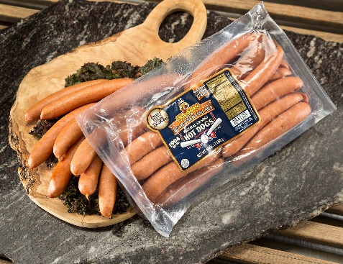
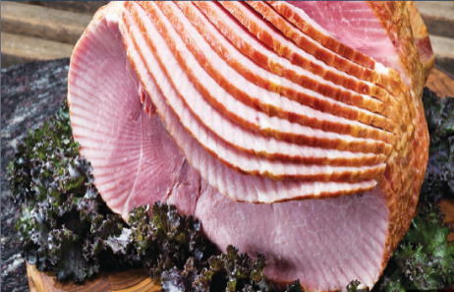
UNGLAZED SPIRAL SLICED HAM
6001- WHOLE (14 LBS) 6002- HALF (8 LBS)
If you prefer to add the glaze yourself, this is the ham for you. Slow-cooked and smoked for up to 24 hours. This product has a shelf life of 19 days from receipt. If it will not be used in that time period, please freeze and then thaw in the refrigerator for 2 days prior to use. Cooking/Serving Suggestion: For best flavor, serve ham at room temperature. Remove ham from refrigerator 15-20 minutes prior to serving. If heating is desired, the best method is to remove slices and heat them to desired temperature. Glaze packet and instructions are included.

KIELBASA
6021- SMOKED KIELBASA (5 LBS)
Try our famous Dearborn Brand smoked kielbasa – a great additon to any dish. Made with beef and pork. Pre-cooked, ready to heat and serve.
6023- FRESH KIELBASA (5 LBS)
Enjoy our fresh Polish kielbasa with garlic. Made with beef and pork.

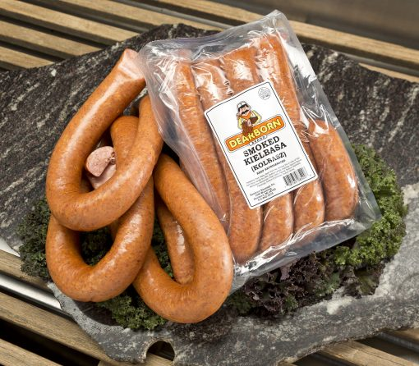

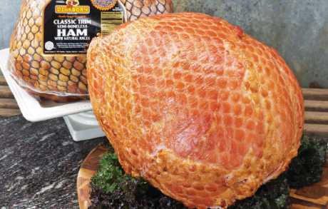
CLASSIC TRIM HAM
6003- WHOLE (14 LBS) 6004- HALF (8 LBS)
Slow-cooked and smoked for up to 24 hours. This product has a shelf life of 7 days from receipt. If it will not be used in that time period, please freeze and then thaw in the refrigerator for 2 days prior to use. Instructions are included on the box.

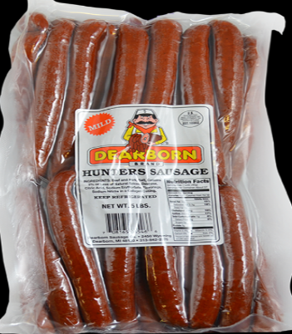
HUNTER SAUSAGE
6026- HOT HUNTER SAUSAGE (5 LBS) - Our famous Dearborrn Brand hot hunter sausage in a great to eat on-the-go or as a quick meal. Made with beef and pork. Fully cooked and ready to eat.
6027- MILD HUNTER SAUSAGE (5 LBS) - Our famous Dearborrn Brand mild hunter sausage in a great to eat on-the-go or as a quick meal. Made with beef and pork. Fully cooked and ready to eat.

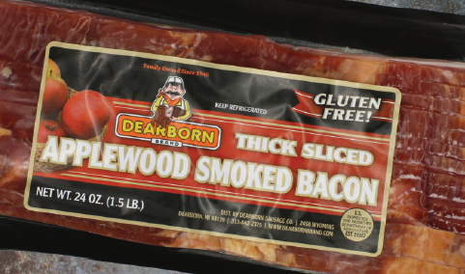
CENTER CUT BACON
6080- HONEY CURED SLICED BACON (1.5 LBS)
6081- APPLEWOOD SLICED BACON (1.5 LBS)

