NEW FUNDRAISER ITEMS!!!!!

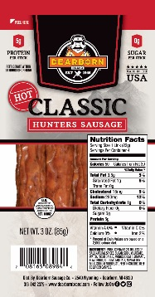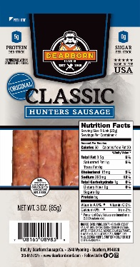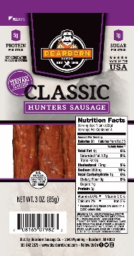

Classic Hunter Sausage
This Hunter Sausage is sure to fuel you up for any adventure. Each stick is packed with 5 grams of protein! 12/3oz packages per case.
6061- Classic Original Hunters $32.00
6062- Classic Hot Hunters $32.00
6063- Classic Teriyaki Hunters $32.00

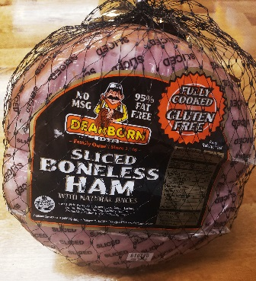
Sliced ¼ Boneless with Glaze Packet
2-4.5lb pieces of Fully Cooked, Pre-sliced, ready to eat Dearborn Ham. This ham is great on sandwiches and perfect as a main dish during the holidays. Gluten and MSG Free. It is recommended to be frozen by the marked sell by date.

6011- Sliced ¼ Boneless with glaze packet $ 24.00

