SMOKED SAUSAGE BACON BOMBS
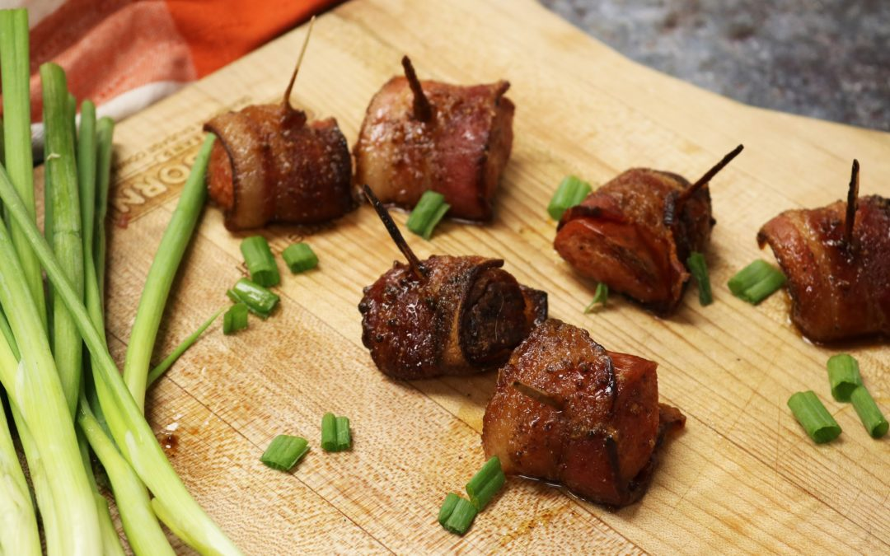

Ingredients:
1 lb. Dearborn Brand Smoked Sausage
10 slices of Dearborn Applewood Smoked Bacon
1 & ½ Cups brown sugar, packed
3 Tbsp stone-ground mustard
3 Tbsp white wine vinegar
1 Tbsp black pepper
Chopped scallions for sprinkling (optional)

Directions:
- Preheat oven to 375°. Line a baking sheet with aluminum foil and spray lightly with non-stick spray.
- Cut smoked sausage done the center, lengthwise. Slice each half into 1 inch pieces, you should have about 30 pieces of smoked sausage. Cut each piece of bacon into thirds. Wrap one bacon strip around each piece of smoked sausage and secure with a toothpick. Set aside.
- In a small saucepan, combine brown sugar, vinegar, mustard and pepper. Heat over medium, stirring occasionally, until the sugar is dissolved. Keep warm on low.
- Brush the smoked sausage with glaze and place on the baking sheet/rack. Bake for 40 minutes and baste every 15 minutes. Serve immediately, and Enjoy!
- Sprinkle with scallions if desired

