DEARBORN SMOKED KIELBASA PASTA
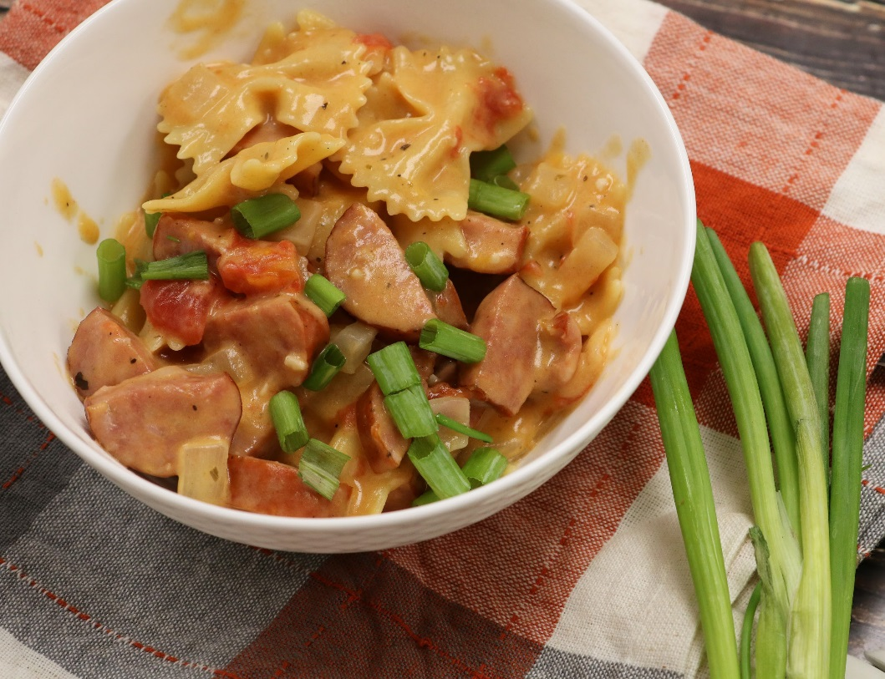

Ingredients:
1 tbsp olive oil
1 lb smoked kielbasa or turkey/chicken sausage sliced 1/4 inch thick
1 & ½ cups diced onion
2 cloves garlic, minced
2 cups low-sodium chicken broth
1 (10 oz) can diced tomatoes
8 oz dry pasta (small pasta)
½ cup milk or heavy cream
½ tsp salt and pepper, each
1 cup shredded Cheddar cheese
⅓ Cup of Thinly Sliced Scallion

Directions:
- Add olive oil to a 4-5 quart saute pan and warm over medium high heat.
- Fry the smoked kielbasa and onions.
- Add garlic and cook until fragrant, about 30 seconds.
- Add chicken broth, tomatoes, heavy cream, pasta, and seasonings.
- Simmer for 15 minutes, or until pasta is tender.
- Remove skillet from heat and stir in 1/2 cup cheese.
- Top with remaining cheese and cover until cheese is melted, spotty brown, and bubbly.
- Sprinkle with sliced scallions and serve, Enjoy!

