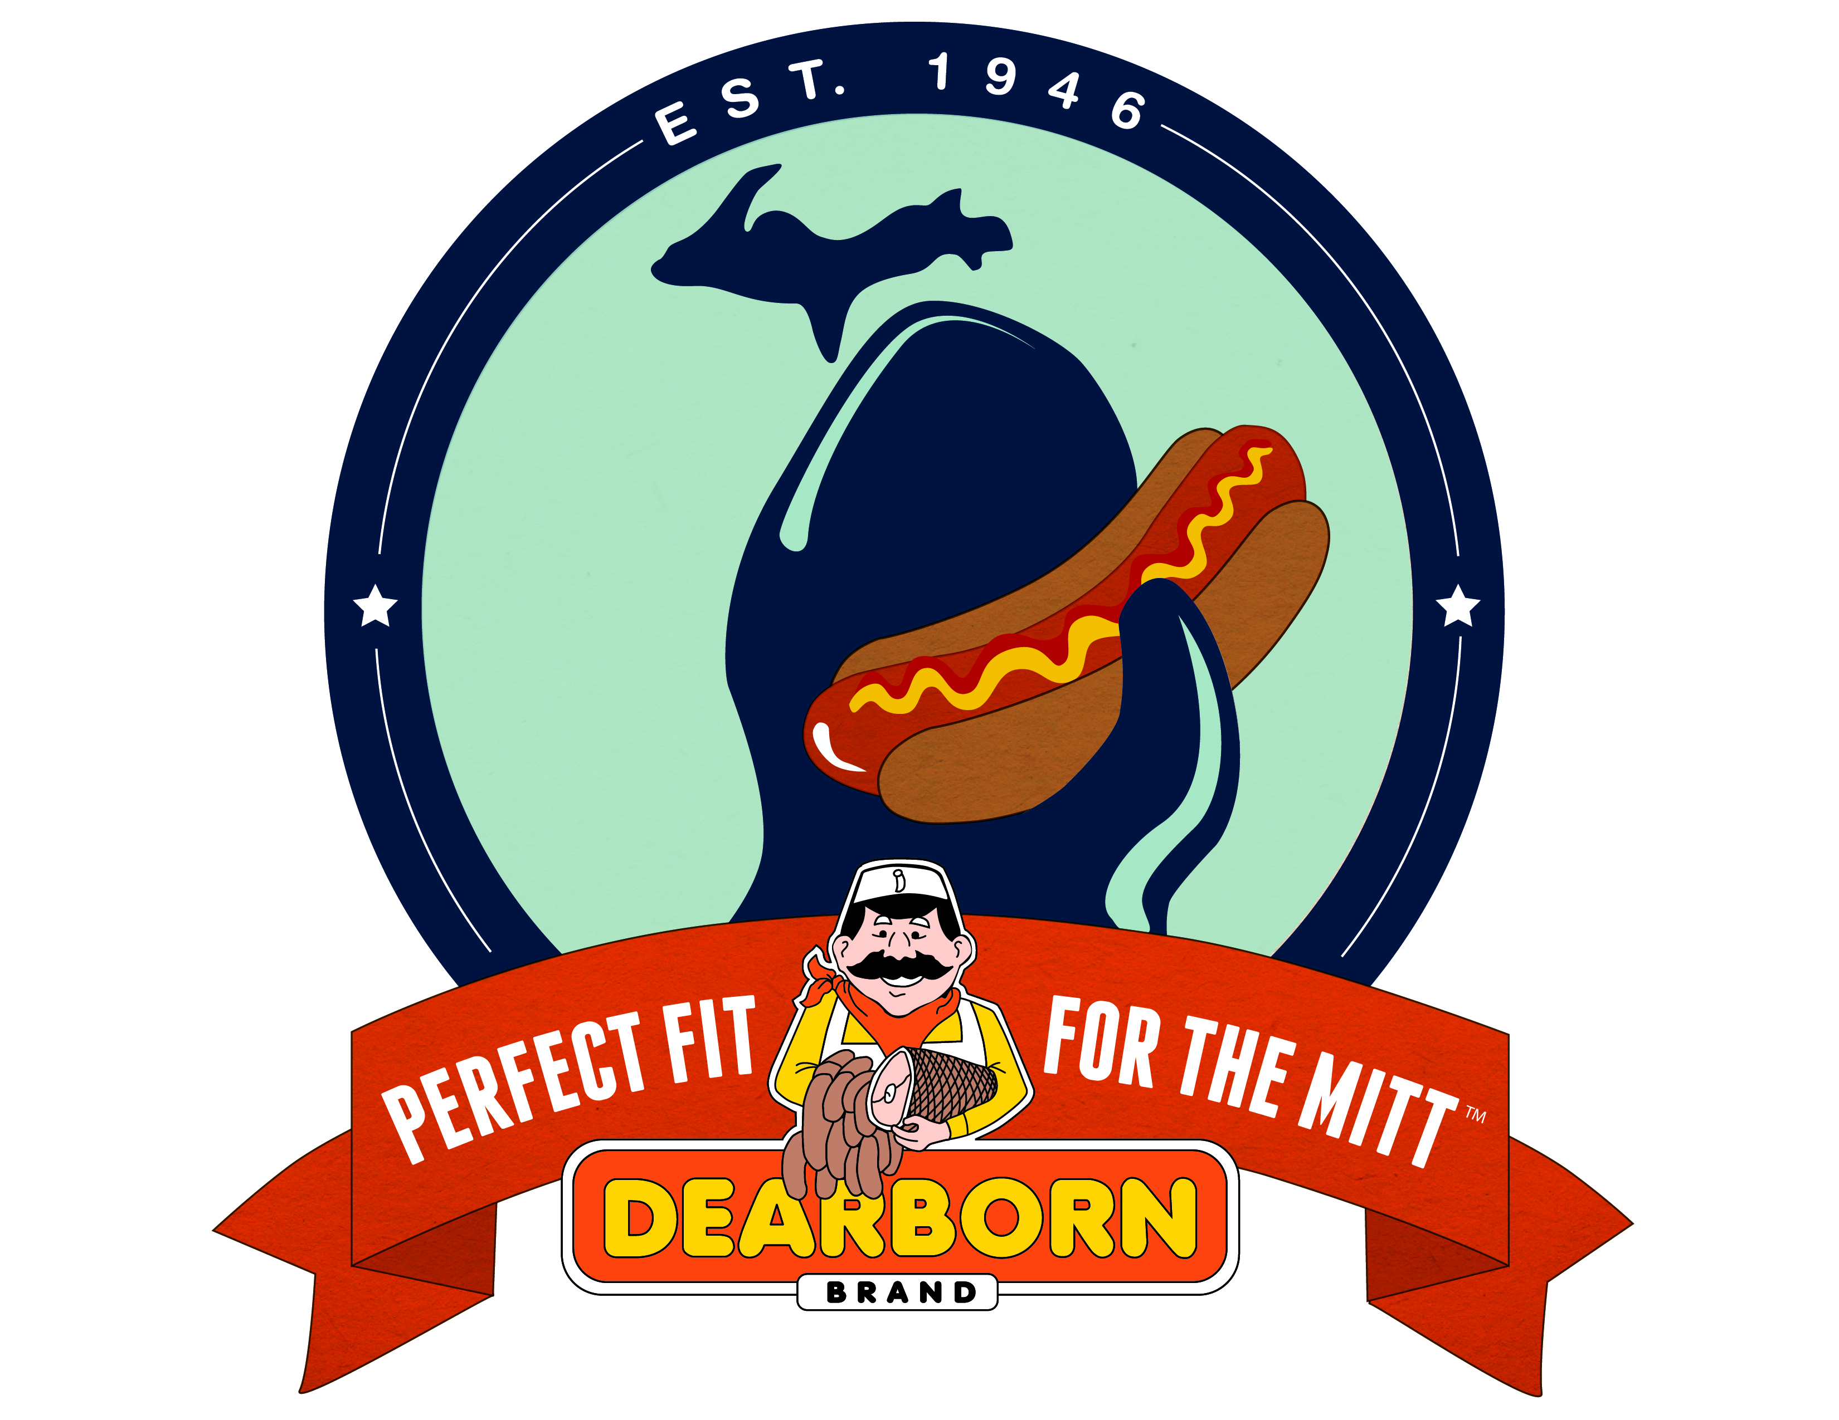  Organization’s Name  Seller’s Name |  | Half Spiral Sliced Torch Glazed Ham - $37.00 | Whole Spiral Sliced Glazed Ham $60.50 | Half Spiral Sliced Ham/Glaze Pkt - $35.00 | Whole Spiral Sliced Ham/Glaze Pkt - $57.00 | Whole Classic Semi Boneless Ham –$45.95 | Half Classic Semi Boneless Ham - $30.50 | Hunters Sausage (Hot) - $31.95 | Hunters Sausage (Mild) - $31.95 | Smoked Kielbasa - $23.50 | Fresh Kielbasa - $23.50 | Spiral Sliced Breast of Turkey - $32.00 | Beef Skinless Franks - $19.00 | Skinless Franks - $17.00 | Natural Casing Franks - $13.00 | Mini Stix (Original) - $36.50 (Sold case only 8 Pks) | Mini Stix (Hot) - $36.50 (Sold case only 8 Pks) | Mini Stix (Teriyaki) - $36.50 (Sold case only 8 Pks) | Mini Stix (Garlic) - $36.50 (Sold case only 8 Pks) | 1904 Brand Hot Dogs -$13.50 | Steakhouse Strips from Angus - $36.50 (Case 8 Pks) | Sweet Bar-b-q Beef Jerky- $36.50 (Case 8Pks) | Hot Hunters Mini Bites - $36.50 (Case 8P ks) | Mild Hunters Mini Bites - $36.50 (Case 8 Pks) | Chicken Kielbasa - $41.00 (Case only 12 Pks) | Chicken Bratwurst-$41.00 (Case only 12 Pks) | Chicken Smoked Jalapeno-$41.00 (Case only 12 Pks) | Chicken Mild Italian-$41.00 (Case only 12 Pks) | Chicken Hot Italian-$41.00 (Case only 12 Pks)
Name | Phone # | 6006 | 6005 | 6002 | 6001 | 6003 | 6004 | 6026 | 6027 | 6021 | 6023 | 6019 | 6040 | 6041 | 6042 | 6051 | 6052 | 6053 | 6054 | 6049 | 6057 | 6058 | 6064 | 6065 | 6073 | 6072 | 6074 | 6070 | 6071
 | TOTALS
TOTAL $

